IMPORTANT INFORMATION
HOODIE SALES- SOUTH COAST CROSS COUNTRY
Please follow buying instructions carefully.
- 2025 South Coast cross country hoodies will be sky blue in colour with navy inside the hood and are $65.
- The online shop for hoodie sales will be open 4pm Friday 30 May- 9:00am Wednesday 11 June ONLY- no products will appear in the catalog before this time (catalog found under South Coast SSA logo). The shop may be accessed by students who were successful at their district (primary) or zone (secondary) carnivals.
- The shop can be accessed under the Merchandise tab on our website https://app.education.nsw.gov.au/sport/SouthCoast
- Purchasers MUST give their mobile phone number when checking out, as there have been issues with email confirmations bouncing back.
- Sales will be by PICK UP ONLY AT THE CARNIVAL- ORDER NUMBER IS ESSENTIAL. IF YOU DO NOT HAVE YOUR ORDER NUMBER PLEASE CALL THE OFFICE ON 4267 6162 OR 4267 6161 AS INTERNET IS VERY SKETCHY SO WE WILL NOT BE ABLE TO LOOK IT UP FOR YOU ON THE DAY. Please note delivery information is still required when checking out.
- Please ensure you add the student’s name, school, and district/ zone in the notes section in your cart- see pic below
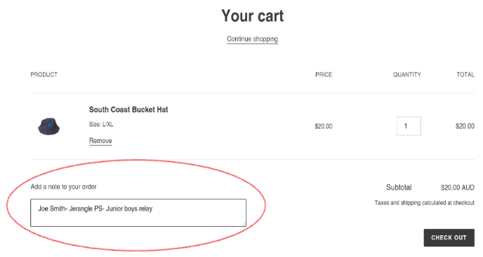

2025 design
