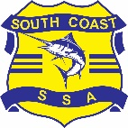
SOUTH COAST SSA PRIMARY ATHLETICS
HOODIE SALES 2025

These will only be sold online through the merchandise tab on the South Coast SSA website https://app.education.nsw.gov.au/sport/SouthCoast/Merchandise

The online shop will be open ONLY from 4:00pm Friday 15 August to 9am Wednesday 3 September, or earlier if sold out. Athletics products will not appear in the catalogue outside of these times.

Items will only be able to be picked up on the day of the carnival- ORDER NUMBER MUST BE PROVIDED. Please note delivery information is still required when checking out.

Mobile number is the preferred option when checking out as some emails have been bouncing back.

All students enrolled in NSW Public Schools who competed at their primary district carnival and qualified to compete at the SCSSA Athletics Championships are eligible to purchase.

Please assist us by adding the student’s name and school in the notes section in your cart.

Limited stock is available, and purchases can only be made by credit card.

In 2025 they are red with black inside the hood and are $65 each. You can also grab yourself some South Coast Jibbitz and lip balm for $5 each.
There MAY be some hoodies left for sale on the day, but these will be CASH ONLY.
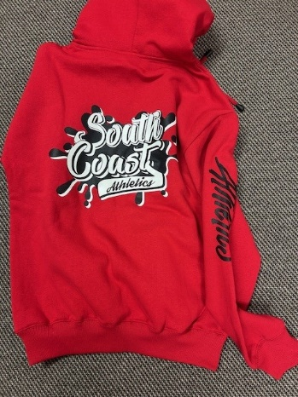
Size guide
XXXS= Junior 8-10
XXS= Junior 10-12
XS = Junior 14 / Ladies 8-10
Adult S = Junior 16 / Ladies 12
Adult M = Ladies 14
Adult L = Ladies 16
Adult XL = Ladies 18

,

